Hong Kong Community College
SEHH1071 Computational Tools for Statistics
In-class Assignment 1
Semester TWO 2020/2021
Name: ___Tsoi Yiu Chik_ Student ID (SID): 20195601A_____ Tutorial: _201B________
The formula entered in Question 1 to 3 should be able to autofill to the rest of the records displayed in this assignment and built-in functions must be included. You SHOULD NOT use the result in the previous sub-parts to do the next parts.

Question 1
The table below shows the records of different animals visiting a veterinary clinic on a particular morning.
The labels (in Row 1) of the animals are standardized in the following format:
Name(semi-colon)(space)4-digit Number(space)Weight(semi-colon)(space)Breed
Note: The lengths of the Name and Breed vary from animal to animal while the Weight must have the unit lb and the Number must be 4 digit.

In each part of this question, the underlined letter R represents the corresponding Column in the following table according to the 8th digit of your Student ID.
8th digit of Student ID | 0 | 1 | 2 | 3 | 4 | 5 | 6 | 7 | 8 | 9
R | B | C | D | E | F | G | H | I | J | K
Write down what should be entered exactly in

- Column R of Row 2 for displaying the “Name” of the animal; (5 marks)

=LEFT(C1,SEARCH(";",C1)-1)
- Column R of Row 3 for displaying the “Number” of the animal; (10 marks)

=MID(C1,SEARCH(" ",C1)+1,5)
- Column R of Row 4 for displaying the “Weight” of the animal; and (15 marks)

=MID(C1,LEN(C2&C3)+4,SEARCH("lb",C1)-LEN(C2&C3)-2)

- Column R of Row 5 for displaying the “Breed” of the animal; (10 marks)
=RIGHT(C1,LEN(C1)-LEN(C2&C3&C4)-5)

Question 2
In the following table, row 3 to row 6 specify the Revision schedule of Crystal in the past 4 days.

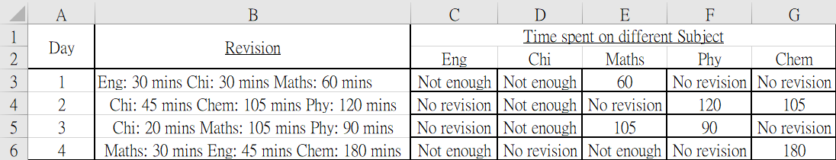

Cell C3 to G6 extract the Time spent on different subjects. Please note that if the revision time is less than 60 mins, a “Not enough” warning should be shown. On the other hand, “No revision” should appear in the cell if the subject was not revised on that day.

(Hint: Please make good use of the ISERROR and NUMBERVALUE functions and be prepared to use more than 1 “IF”)
(15 marks)
As an example, the following 3 lines show the format in cell B3
Subject(colon)(space)number(space)mins(space)
Subject(colon)(space)number(space)mins(space)
Subject(colon)(space)number(space)mins
Cell B4, B5 and B6 are in the same format as B3.

Write down what should be entered exactly in Cell E3 in which the answer can also be applied to other cells.
=IF(ISERROR(SEARCH(E$2,$B3,1)),"No Revision",IF(NUMBERVALUE(MID($B3,SEARCH(E$2,$B3,1)+LEN(E$2)+2,3))<60,"Not enough",NUMBERVALUE(MID($B3,SEARCH(E$2,$B3,1)+LEN(E$2)+2,3))))

Question 3
Worksheet A shows the record for the product in a retail store. (In this question, use the 8th digit of your student ID as X.)
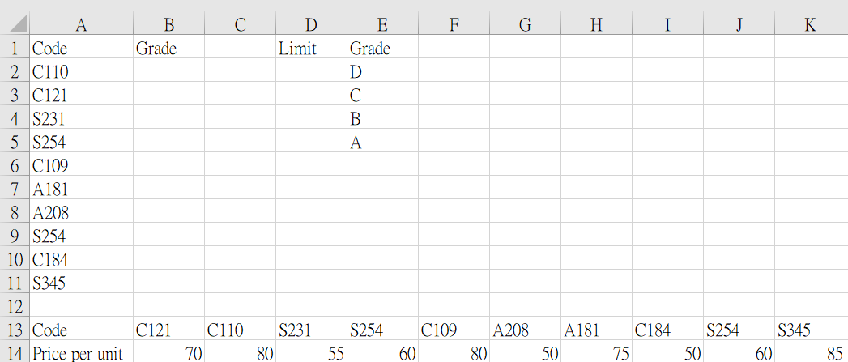
Worksheet A

The owner is going to assign grades to products according to the price range (in integer) in the following table.
Grade | Range of prices
D | 0 to X+50
C | X+51to X+60
B | X+61 to X+80
A | X+81 to 100

- Write down the values of the limits from D2 to D5 of Worksheet A in the following table.
(5 marks)
Limit | Grade
51 | D
61 | C
81 | B
100 | A

- Write down what exactly should be entered in the cell B(2+X) for obtaining the grade of the product with pricing information, grading table and appropriate lookup function. You are not allowed to add extra rows and columns to complete the task. You need to use more than 1 lookup function in the cell.
(10 marks)

____________________________________________________________________________________________________________________________________________________________________________

Question 4
- Determine the levels of measurement for the following variables. (15 marks)

- Breed of the dog
- Booking time for visiting the veterinary clinic (e.g. 9:30am…)
- Satisfaction level towards the service in the veterinary clinic (Satisfied, Neutral, Unsatisfied)

- Which of the following is the population of a study about the view of the pet owners over the service quality in Smart veterinary clinic? (5 marks)
- All the pet owners
- All the selected pet owners in Smart veterinary clinic
- All the pet owners who have visited Smart veterinary clinic
- Pet owners in Smart veterinary clinic at the moment of the interview
Ans: ________
- Determine whether each of the following statements is a descriptive statistics or an inferential statistics.
(10 marks)
- The vet predicts that the dog will gain 10 pounds in the coming year.
- The average age of the dog visiting the veterinary clinic in the last month was 2.5 years old.

End of In-class Assignment 1

